Q1. Matrix Addition
Implement a program in CUDA to add two matrices for the following specifications:
a. Each row of the resultant matrix to be computed by one thread.
b. Each column of the resultant matrix to be computed by one thread.
c. Each element of the resultant matrix to be computed by one thread.

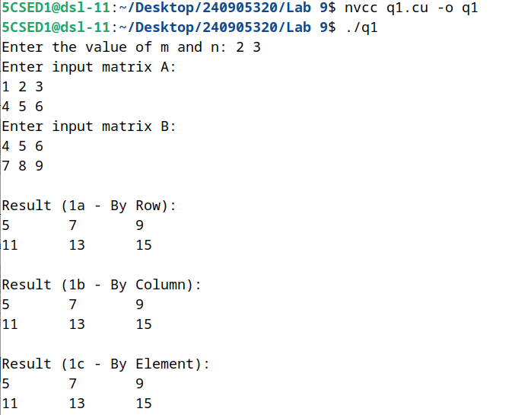

Q2. Matrix Multiplication
Implement a program in CUDA to multiply two matrices for the following specifications:
a. Each row of the resultant matrix to be computed by one thread.
b. Each column of the resultant matrix to be computed by one thread.
c. Each element of the resultant matrix to be computed by one thread.

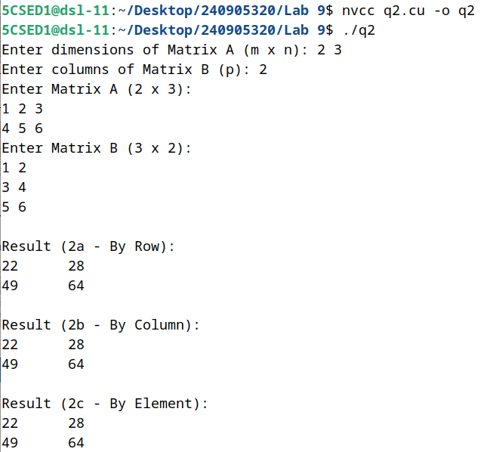
Q3. Sparse Matrix–Vector Multiplication
Implement a program in CUDA to perform parallel Sparse Matrix–Vector multiplication using compressed sparse row (CSR) storage format.
Represent the input sparse matrix in CSR format in the host code.
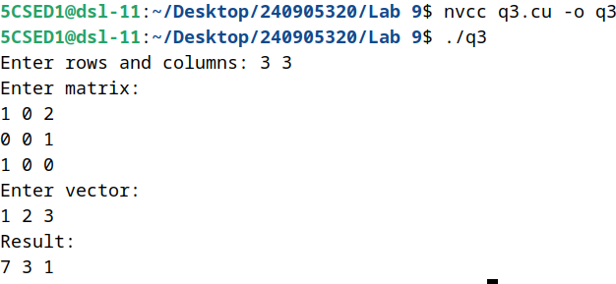
Q4. Row-wise Matrix Transformation
Implement a program in CUDA to read an M×N matrix A and replace:
- 1st row with the same elements.
- 2nd row elements by the square of each element.
- 3rd row elements by the cube of each element.
- And so on.
